1. 
2. I’ll introduce you a tool that lets you send RESTful Request and see the response. I’m talking about REST API client.
3. Some part of the REST API Client, you can do with browser by entering the resource URL but that would make only GET request but we want to make other requests too and along with that we want to send a good amount of data too and see the response in detail.
4. So, we will look at the tool that allows us to do that. 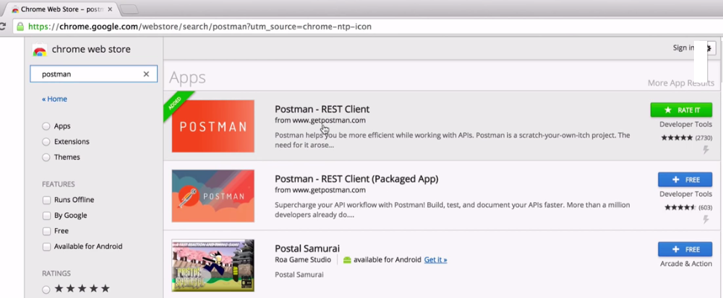
5. 